附件1：

Nike, Inc.v. Schedule A
涉案商标信息

Registration Number | Trademark | Goods and Services
978952 | NIKE  (word mark) | For: Athletic shoes with spikes and athletic uniforms for use with such shoes in class 025.  For: Athletic shoes without spikes and athletic uniforms for use with such shoes in class 025.
1153938 | NIKE  (word mark) | For: All purpose sports bags, travel bags, hand bags and shoulder bags in class 018.
1214930 | NIKE  (word mark) | For: Footwear in class 025.
1945654 | NIKE  (word mark) | For: Full line of sports clothing in class 025.
1277066 | NIKE  (word mark) | For: Athletic and casual clothing for men, women and children- namely, shirts, pants, shorts, jackets, warm-up suits, headwear, socks in class 025.

4704670 | NIKE  (word mark) | For: Eyewear; sunglasses; goggles for sports; computer application software for smart phones and mobile devices, namely, software for social networking, receipt and transmission of data, fitness, and fitness assessments; computer software for fitness and fitness assessments; sensors and electronic monitoring devices incorporating microprocessors, digital display, and accelerometers, for detecting, storing, reporting, monitoring, uploading and downloading sport, fitness training, and activity data to the internet, mobile devices, and communication with mobile devices, computers, and electronic devices in class 009.

1307123 | NIKE AIR  (word mark) | For: Footwear and Cushioning Elements for Footwear Soles in class 025.
3192901 | NIKE FREE  (word mark) | For: Footwear in class 025.
977190 | 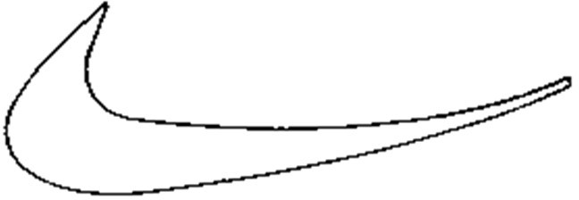 | For: Athletic shoes with spikes and athletic uniforms for use with such shoes in class 025.  For: Athletic shoes without spikes and athletic uniforms for use with such shoes in class 025.
1145473 | 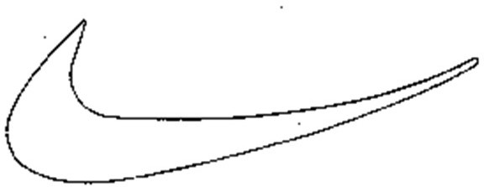 | For: All Purpose Sports Bags, Travel Bags, Hand Bags and Shoulder Bags in class 018.
1323343 |  | For: Footwear in class 025.
4704672 | 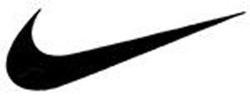 | For: Eyewear; sunglasses; goggles for sports; computer application software for smart phones and mobile devices, namely, software for social networking, receipt and transmission of data, fitness, and fitness assessments; computer software for fitness and fitness assessments; sensors and electronic monitoring devices incorporating microprocessors, digital display, and accelerometers, for detecting, storing, reporting, monitoring, uploading and downloading sport, fitness training, and activity data to the internet, mobile devices, and communication with mobile

 |  | devices, computers, and electronic devices in class 009.
1284385 |  | For: Athletic and Casual Clothing for Men, Women and Children- Namely, Shirts, Pants, Shorts, Jackets, Warm-Up Suits, Swimwear, Tenniswear, Skirts, Sweaters, Underwear, Headwear, Socks and Wristbands in class 025.
1990180 |  | For: full line of sports clothing in class 025.
2068075 |  | For: footwear and clothing, namely caps, socks and sweatshirts in class 025.
1571066 | 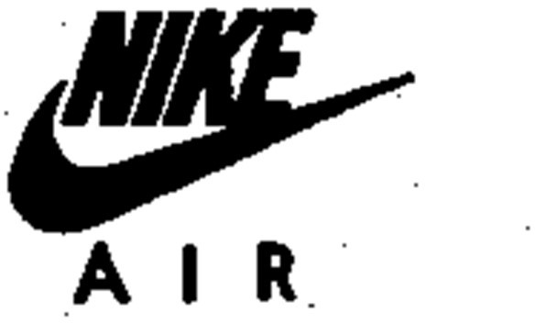 | For: Clothing, namely t-shirts in class 025.
1284386 | 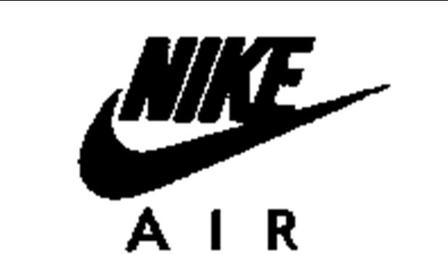 | For: Footwear in class 025.

1237469 | 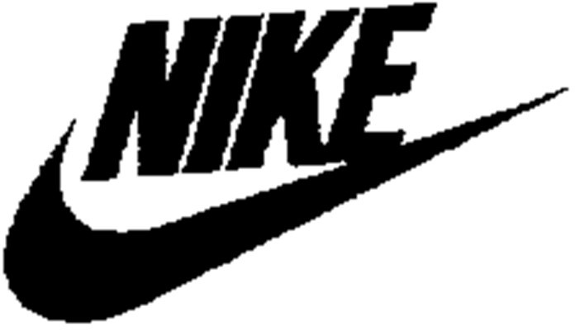 | For: Athletic and casual clothing for men, women and children- namely, shirts, pants, shorts, jackets, warm-up suits, swimwear, sweaters, underwear, headwear, and socks, handwear in class 025
1325938 | 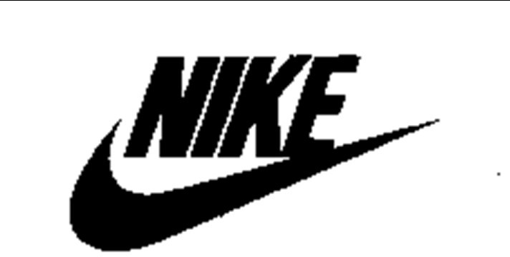 | For: Footwear in class 025.
1772987 | 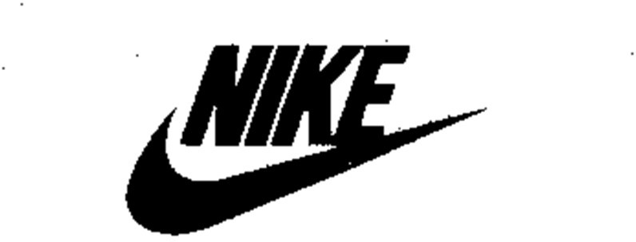 | For: All-purpose sports bags, backpacks and duffle bags in class 018.
2104329 | 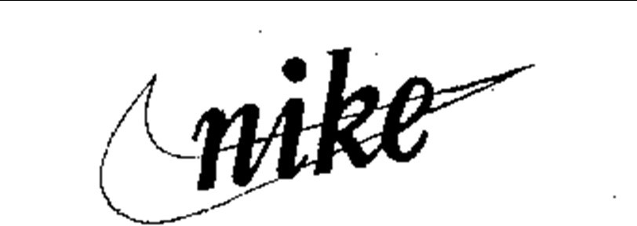 | For: Footwear in class 025.
4764071 | JUST DO IT  (word mark) | For: All purpose sport bags; Backpacks in class 018.  For: Footwear; Headbands; Headwear; Pants; Shorts; Sports bras; Tank tops; Tights; Warm up suits in class 025.
1875307 | JUST DO IT.  (word mark) | For: Clothing, namely t-shirts, sweatshirts and caps in class 025.
1200529 | SWOOSH  (word mark) | For: footwear in class 025.

2164810 | SWOOSH  (word mark) | For: clothing namely, socks and T- shirts in class 025.
1508348 | AIR MAX  (word mark) | For: footwear in class 025.
1789463 | AIR TRAINER MAX  (word mark) | For: footwear in class 025.
5503242 | VAPORMAX  (word mark) | For: Footwear in class 025.
5286596 | NIKE AIR VAPORMAX  (word mark) | For: Footwear in class 025.
2716140 | PRESTO  (word mark) | For: Footwear in class 025.
3370246 | LEBRON  (word mark) | For: Footwear; apparel, namely, shirts, pants, shorts, caps, hats, tank tops, t-shirts, pullovers, sweatshirts, jackets, socks in class 025.
3412757 | LEBRON  (word mark) | For: All-purpose sports bags, backpacks, and shoe bags for travel in class 018.
1370283 | AIR JORDAN  (word mark) | For: footwear and athletic clothing, namely, shirts, pants, shorts in class 025.
1686515 | AIR FLIGHT  (word mark) | For: footwear in class 025.
4210496 | MERCURIAL  (word mark) | For: Bags, namely, all-purpose sports bags, tote bags, duffle bags, messenger bags and backpacks in class 018.  For: Footwear in class 025.
3780236 | DUNK  (word mark) | For: athletic footwear, not to include shoe care products in class 025.
4902368 | AIR FORCE 1  (word mark) | For: Apparel, namely, shirts, t- shirts; headwear, namely, hats, caps in class 025.
3520484 | AIR FORCE 1  (word mark) | For: Footwear in class 025.

1027021 | CORTEZ  (word mark) | For: Athletic shoes for track and field in class 025.
1794058 | DRI-FIT  (word mark) | For: clothing; namely, (( pants, )) shorts, tights, tops, and shirts in class 025.
2571314 | DRI-FIT  (word mark) | For: Clothing, namely, caps, dresses, headbands, jackets, skirts, socks, sports bras, sweatshirts, t- shirts, underwear in class 025.  For: Sporting goods, namely, soccer shinguards in class 028.
1887959 | DRI-FIT  (word mark) | For: clothing; namely, singlets, and vests in class 025.
4393310 | FLYKNIT  (word mark) | For: footwear in class 025.
5700611 | TECHKNIT  (word mark) | For: Apparel, namely, capri pants, pants, sweatpants, shorts, tank tops, t-shirts, short-sleeved shirts, long- sleeved shirts, sweatshirts, jackets, hats, caps in class 025.
1839775 | THERMA-FIT  (word mark) | For: clothing; namely, pants, sweatpants, jackets, sweatshirts, and vests in class 025.
1558100 | 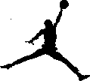 | For: Footwear, t-shirts, shorts, pullovers, pants, warm-up suits and tank tops in class 025.
1742019 | 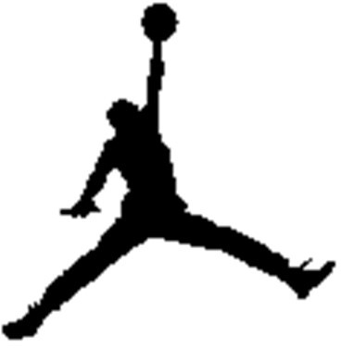 | For: all-purpose sports bags and backpacks in class 018.  For: footwear and clothing, namely pants, shorts, shirts, t-shirts, sweatshirts, tank tops, warm-up suits, jackets, hats, caps, and socks in class 025.

3725535 | 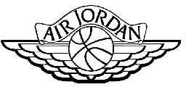 | For: Footwear; Apparel, namely, shirts, pants, shorts; Jackets, hats; Sweatshirt in class 025.
4254513 |  | For: Backpacks, duffle bags, drawstring pouches in class 018  For: Footwear; apparel, namely, jerseys, pants, shorts, t-shirts, shirts, sweatshirts, hooded sweatshirts, sweatpants, vests, tank tops, jackets, coats, socks, wrist bands, headbands, headwear, hats, caps, sweatbands, sweaters in class 025.  For: Sports balls; basketballs in class 028.
5392140 | 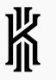 | For: All-purpose sports bags, backpacks, duffle bags, tote bags, gym bags, drawstring pouches in class 018  For: Footwear; headwear; hats, caps, headbands, sweatbands; apparel, namely, pants, shorts, shirts, t-shirts, pullovers, jerseys, sweat shirts, sweat pants, sweaters, jackets, socks, vests, hoods in class 025.
3580156 | 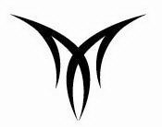 | For: Footwear; apparel, namely, shirts, t-shirts, tops in class 025.
4462766 | 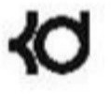 | For: Backpacks in class 018.  For: T-shirts, shirts, sweatshirts, pants, shorts, jackets, tops, socks, footwear in class 025.

3451904 | 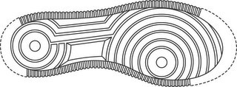 | For: Footwear in class 025.
3451905 | 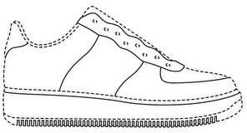 | For: Footwear in class 025.
5820374 | 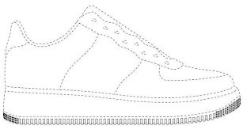 | For: Footwear in class 025.
3451906 | 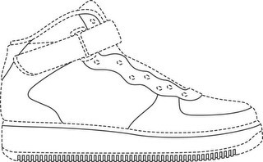 | For: Footwear in class 025.
3451907 | 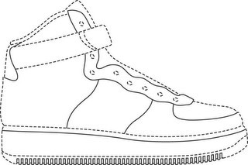 | For: Footwear in class 025.
6368691 | 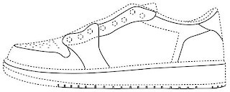 | For: Footwear in class 025.
6368693 | 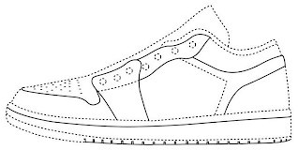 | For: Footwear in class 025.

6368694 | 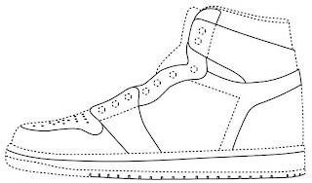 | For: Footwear in class 025.
6682467 | 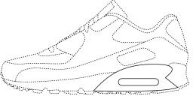 | For: Footwear in class 025.
6682468 | 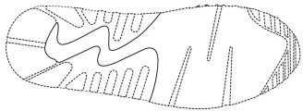 | For: Footwear in class 025.

3192901 | NIKE FREE  (word mark) | For: Footwear in class 025.
977190 |  | For: Athletic shoes with spikes and athletic uniforms for use with such shoes in class 025.  For: Athletic shoes without spikes and athletic uniforms for use with such shoes in class 025.
1145473 |  | For: All Purpose Sports Bags, Travel Bags, Hand Bags and Shoulder Bags in class 018.
1323343 |  | For: Footwear in class 025.
4704672 |  | For: Eyewear; sunglasses; goggles for sports; computer application software for smart phones and mobile devices, namely, software for social networking, receipt and transmission of data, fitness, and fitness assessments; computer software for fitness and fitness assessments; sensors and electronic monitoring devices incorporating microprocessors, digital display, and accelerometers, for detecting, storing, reporting, monitoring, uploading and downloading sport, fitness training, and activity data to the internet, mobile devices, and communication with mobile

 |  | devices, computers, and electronic devices in class 009.
1284385 |  | For: Athletic and Casual Clothing for Men, Women and Children- Namely, Shirts, Pants, Shorts, Jackets, Warm-Up Suits, Swimwear, Tenniswear, Skirts, Sweaters, Underwear, Headwear, Socks and Wristbands in class 025.
1990180 |  | For: full line of sports clothing in class 025.
2068075 |  | For: footwear and clothing, namely caps, socks and sweatshirts in class 025.
1571066 |  | For: Clothing, namely t-shirts in class 025.
1284386 |  | For: Footwear in class 025.

1237469 |  | For: Athletic and casual clothing for men, women and children- namely, shirts, pants, shorts, jackets, warm-up suits, swimwear, sweaters, underwear, headwear, and socks, handwear in class 025
1325938 |  | For: Footwear in class 025.
1772987 |  | For: All-purpose sports bags, backpacks and duffle bags in class 018.
2104329 |  | For: Footwear in class 025.
4764071 | JUST DO IT  (word mark) | For: All purpose sport bags; Backpacks in class 018.  For: Footwear; Headbands; Headwear; Pants; Shorts; Sports bras; Tank tops; Tights; Warm up suits in class 025.
1875307 | JUST DO IT.  (word mark) | For: Clothing, namely t-shirts, sweatshirts and caps in class 025.
1200529 | SWOOSH  (word mark) | For: footwear in class 025.

2164810 | SWOOSH  (word mark) | For: clothing namely, socks and T- shirts in class 025.
1508348 | AIR MAX  (word mark) | For: footwear in class 025.
1789463 | AIR TRAINER MAX  (word mark) | For: footwear in class 025.
5503242 | VAPORMAX  (word mark) | For: Footwear in class 025.
5286596 | NIKE AIR VAPORMAX  (word mark) | For: Footwear in class 025.
2716140 | PRESTO  (word mark) | For: Footwear in class 025.
3370246 | LEBRON  (word mark) | For: Footwear; apparel, namely, shirts, pants, shorts, caps, hats, tank tops, t-shirts, pullovers, sweatshirts, jackets, socks in class 025.
3412757 | LEBRON  (word mark) | For: All-purpose sports bags, backpacks, and shoe bags for travel in class 018.
1370283 | AIR JORDAN  (word mark) | For: footwear and athletic clothing, namely, shirts, pants, shorts in class 025.
1686515 | AIR FLIGHT  (word mark) | For: footwear in class 025.
4210496 | MERCURIAL  (word mark) | For: Bags, namely, all-purpose sports bags, tote bags, duffle bags, messenger bags and backpacks in class 018.  For: Footwear in class 025.
3780236 | DUNK  (word mark) | For: athletic footwear, not to include shoe care products in class 025.
4902368 | AIR FORCE 1  (word mark) | For: Apparel, namely, shirts, t- shirts; headwear, namely, hats, caps in class 025.
3520484 | AIR FORCE 1  (word mark) | For: Footwear in class 025.

1027021 | CORTEZ  (word mark) | For: Athletic shoes for track and field in class 025.
1794058 | DRI-FIT  (word mark) | For: clothing; namely, (( pants, )) shorts, tights, tops, and shirts in class 025.
2571314 | DRI-FIT  (word mark) | For: Clothing, namely, caps, dresses, headbands, jackets, skirts, socks, sports bras, sweatshirts, t- shirts, underwear in class 025.  For: Sporting goods, namely, soccer shinguards in class 028.
1887959 | DRI-FIT  (word mark) | For: clothing; namely, singlets, and vests in class 025.
4393310 | FLYKNIT  (word mark) | For: footwear in class 025.
5700611 | TECHKNIT  (word mark) | For: Apparel, namely, capri pants, pants, sweatpants, shorts, tank tops, t-shirts, short-sleeved shirts, long- sleeved shirts, sweatshirts, jackets, hats, caps in class 025.
1839775 | THERMA-FIT  (word mark) | For: clothing; namely, pants, sweatpants, jackets, sweatshirts, and vests in class 025.
1558100 |  | For: Footwear, t-shirts, shorts, pullovers, pants, warm-up suits and tank tops in class 025.
1742019 |  | For: all-purpose sports bags and backpacks in class 018.  For: footwear and clothing, namely pants, shorts, shirts, t-shirts, sweatshirts, tank tops, warm-up suits, jackets, hats, caps, and socks in class 025.

3725535 |  | For: Footwear; Apparel, namely, shirts, pants, shorts; Jackets, hats; Sweatshirt in class 025.
4254513 |  | For: Backpacks, duffle bags, drawstring pouches in class 018  For: Footwear; apparel, namely, jerseys, pants, shorts, t-shirts, shirts, sweatshirts, hooded sweatshirts, sweatpants, vests, tank tops, jackets, coats, socks, wrist bands, headbands, headwear, hats, caps, sweatbands, sweaters in class 025.  For: Sports balls; basketballs in class 028.
5392140 |  | For: All-purpose sports bags, backpacks, duffle bags, tote bags, gym bags, drawstring pouches in class 018  For: Footwear; headwear; hats, caps, headbands, sweatbands; apparel, namely, pants, shorts, shirts, t-shirts, pullovers, jerseys, sweat shirts, sweat pants, sweaters, jackets, socks, vests, hoods in class 025.
3580156 |  | For: Footwear; apparel, namely, shirts, t-shirts, tops in class 025.
4462766 |  | For: Backpacks in class 018.  For: T-shirts, shirts, sweatshirts, pants, shorts, jackets, tops, socks, footwear in class 025.

3451904 |  | For: Footwear in class 025.
3451905 |  | For: Footwear in class 025.
5820374 |  | For: Footwear in class 025.
3451906 |  | For: Footwear in class 025.
3451907 |  | For: Footwear in class 025.
6368691 |  | For: Footwear in class 025.
6368693 |  | For: Footwear in class 025.

6368694 |  | For: Footwear in class 025.
6682467 |  | For: Footwear in class 025.
6682468 |  | For: Footwear in class 025.

